Video links HERE :

Original size : - https://drive.google.com/file/d/1hirS1LnQHNratbDuo3EyupDbaP1G2SIF/view?usp=sharing

Compressed size : – https://drive.google.com/file/d/1KPY1FSttDh3kukG8csw0hVH3Awubfn7E/view?usp=sharing

Question 1 code :

Sort() – to sort the list

Calculated median with middle position(6) which was obtained by dividing length of list (12)

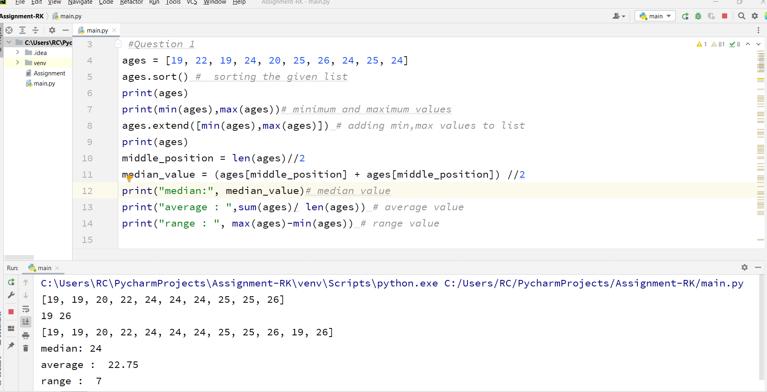

Question 2 :

Created 2 empty dictionaries ‘dog’ and ‘Student’ and assigned them with respective keys and values

Created a list ‘ValuesofSkill’ which is used as a value for key ‘Skills’

Used extend() to add multiple values to list ‘ValuesofSkill’

Used keys(),values() to print all keys and values of dictionary Student

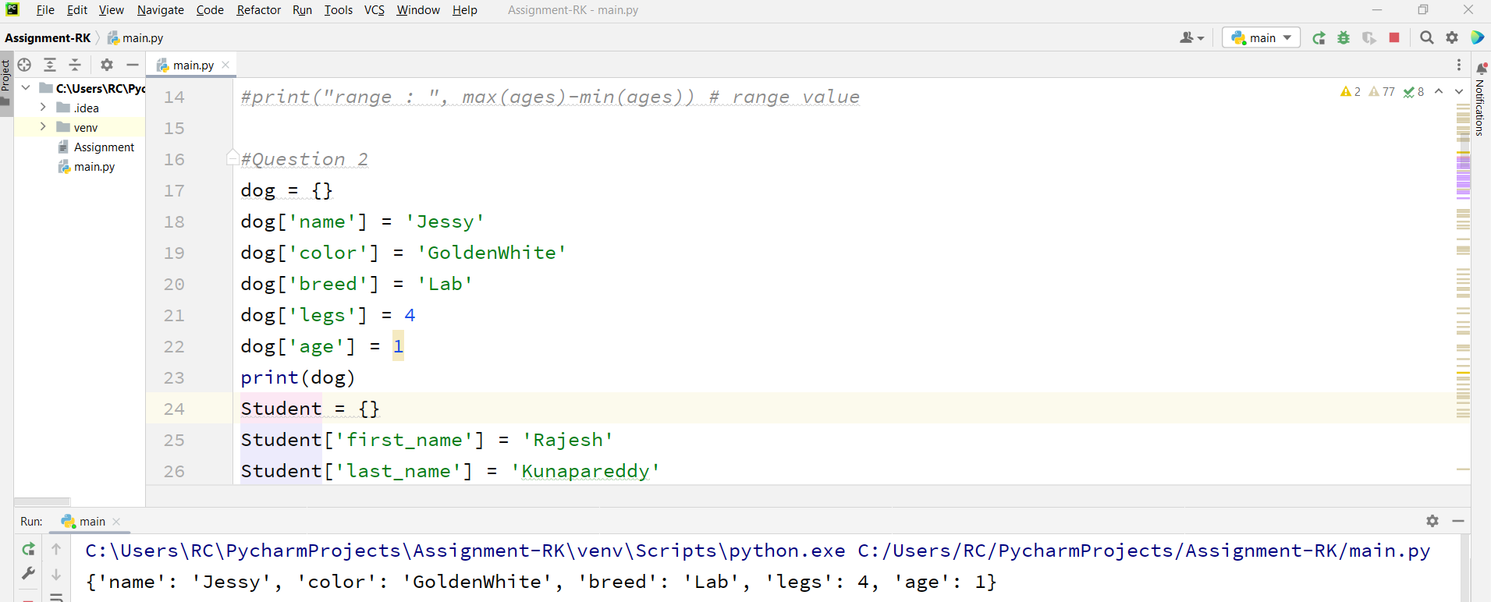

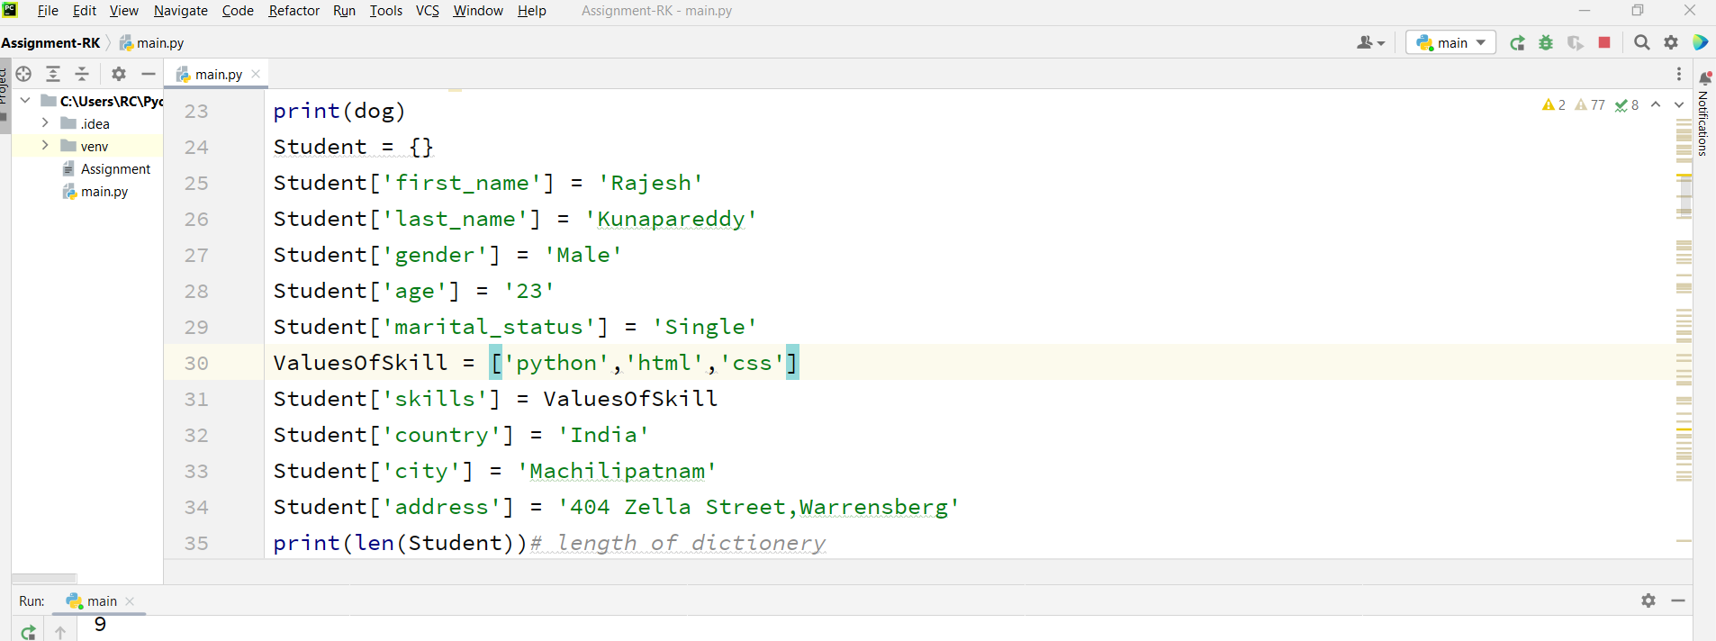

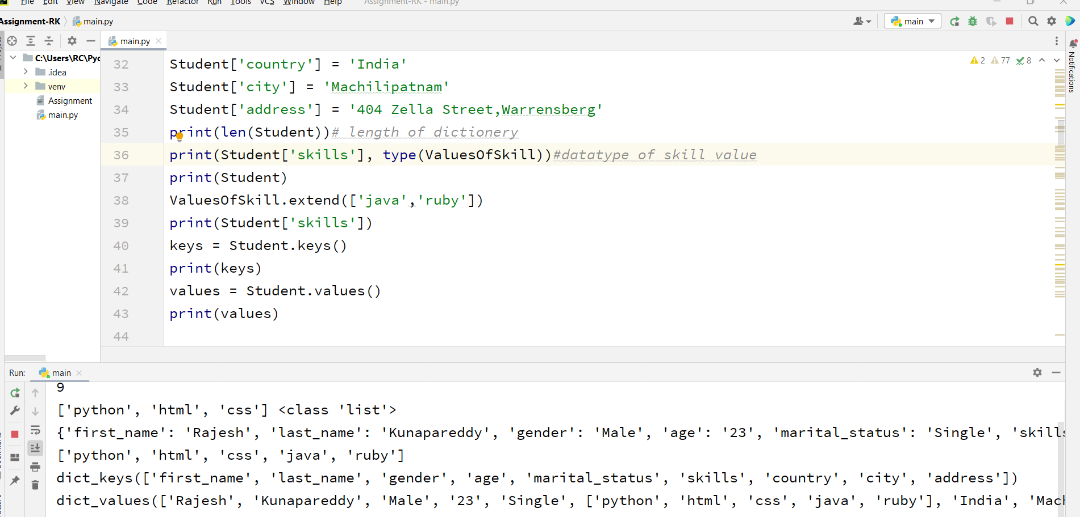

Question 3 :

Created tuples ‘brothers’ and ‘sisters’ and joined them using ‘+’ and assigned to Siblings

Len() – to find length of siblings , and I created Family tuple by joining siblings with parent tuple values

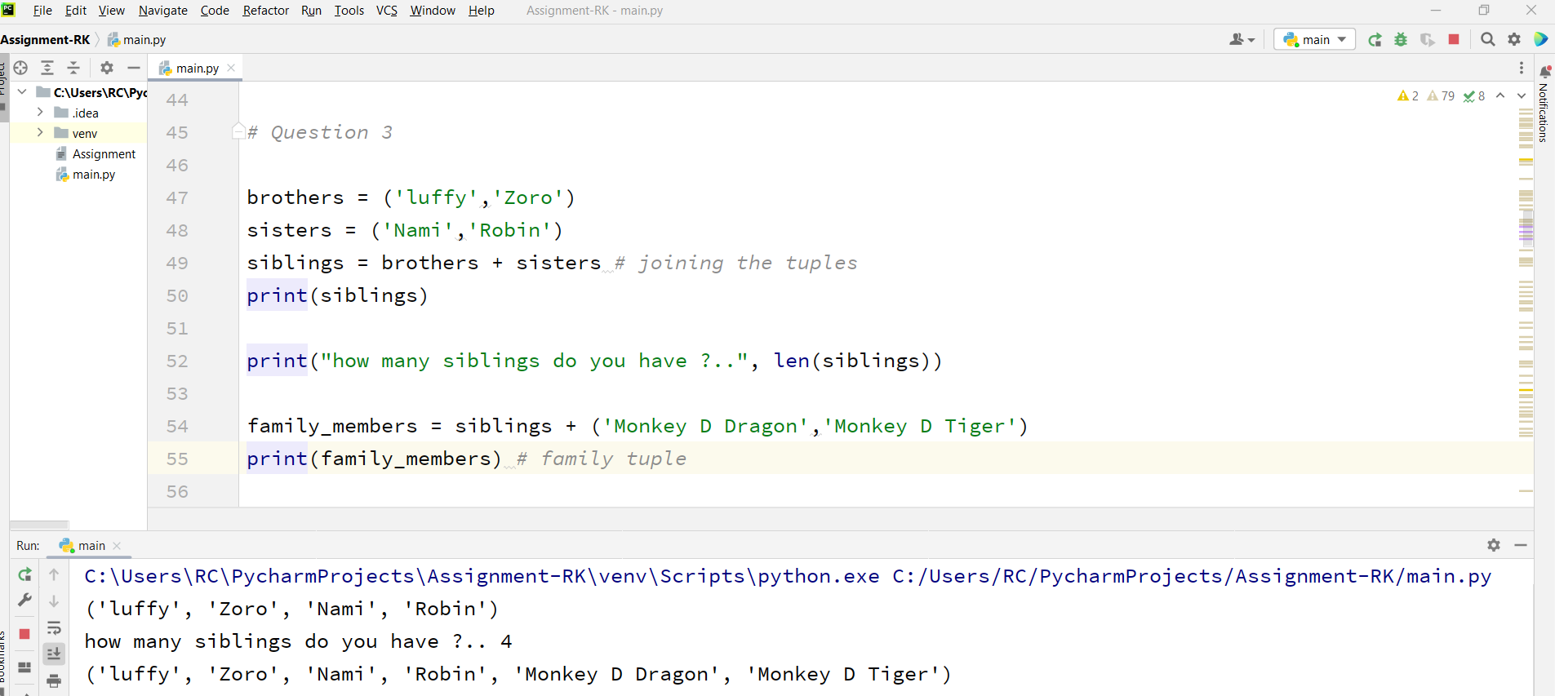

Question 4:

Created two sets A,B and did union , intersection with union(),intersection()

Found symmetric difference with symmetric_difference() and deleted A,B completely

Created a set ‘age2’ by converting list ‘age’ to a set

Compared length of age and age2

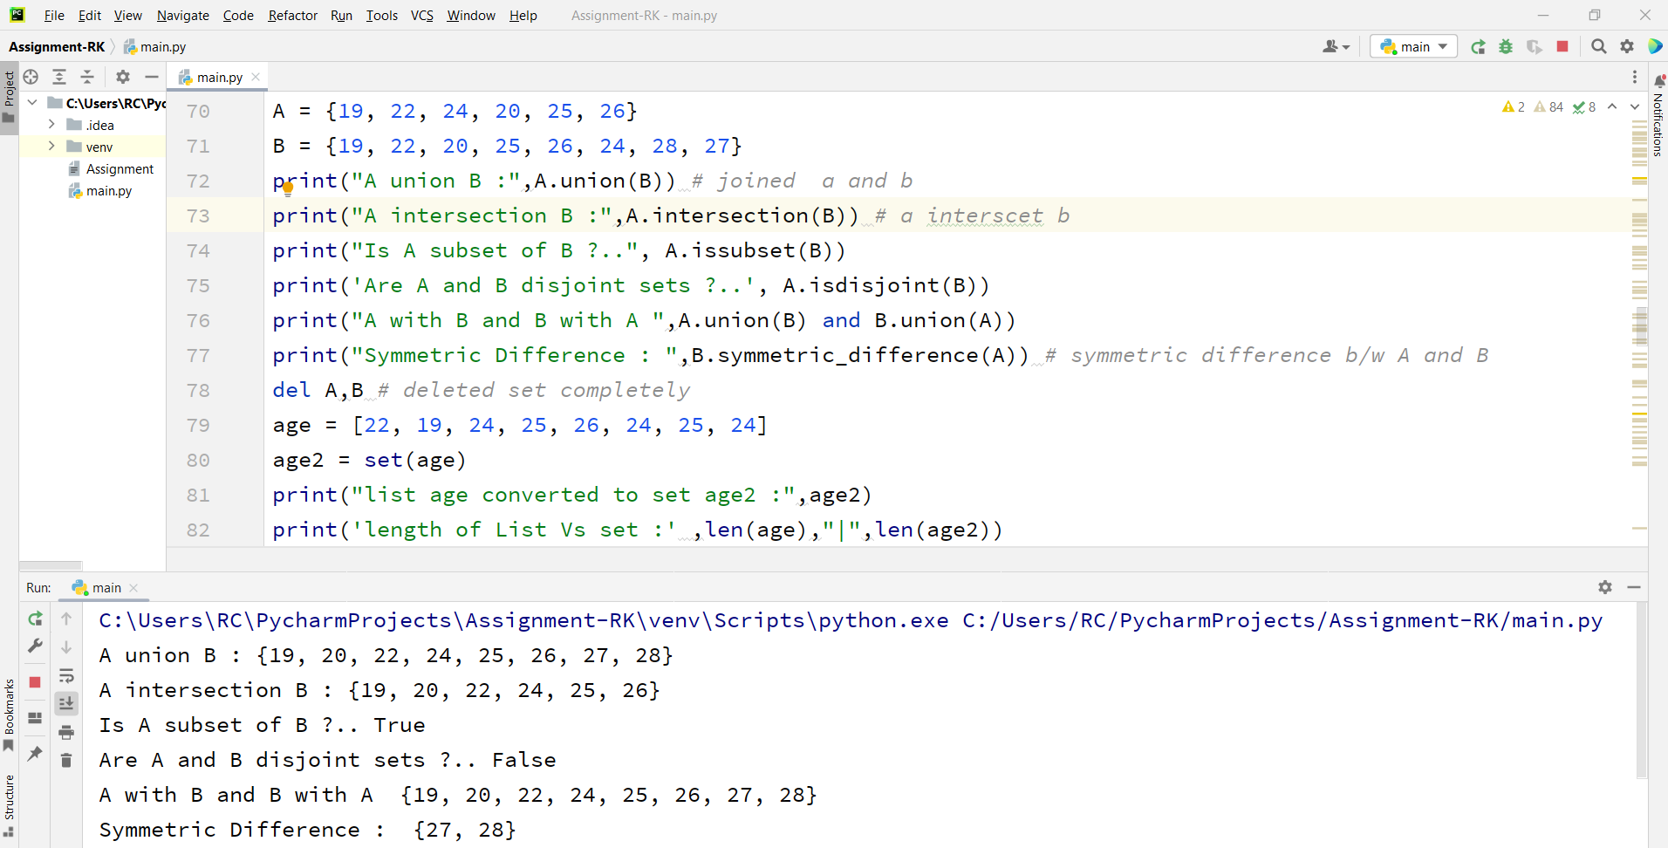

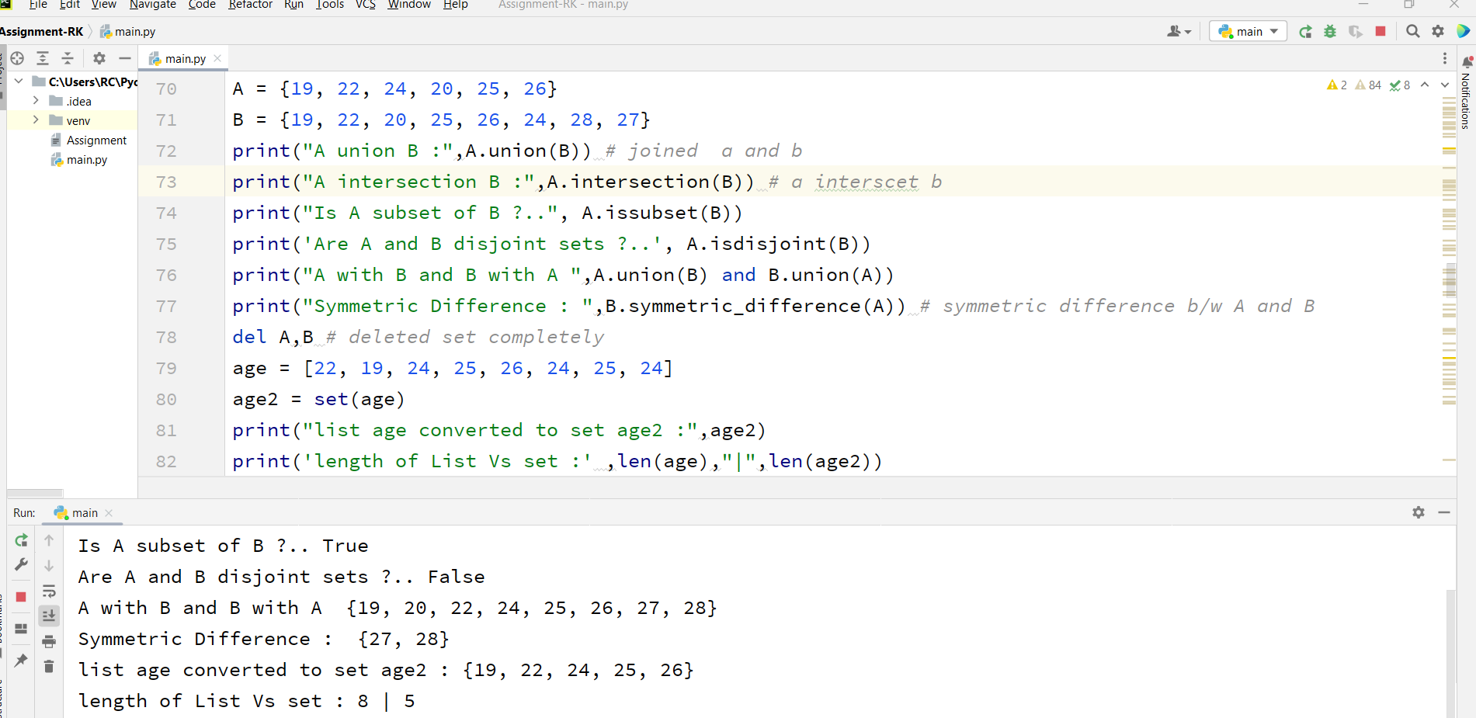

Created a set ‘it_companies’,found lengthand added twitter to it

Added multiple values to the set ,removed microsoft and printed the set.

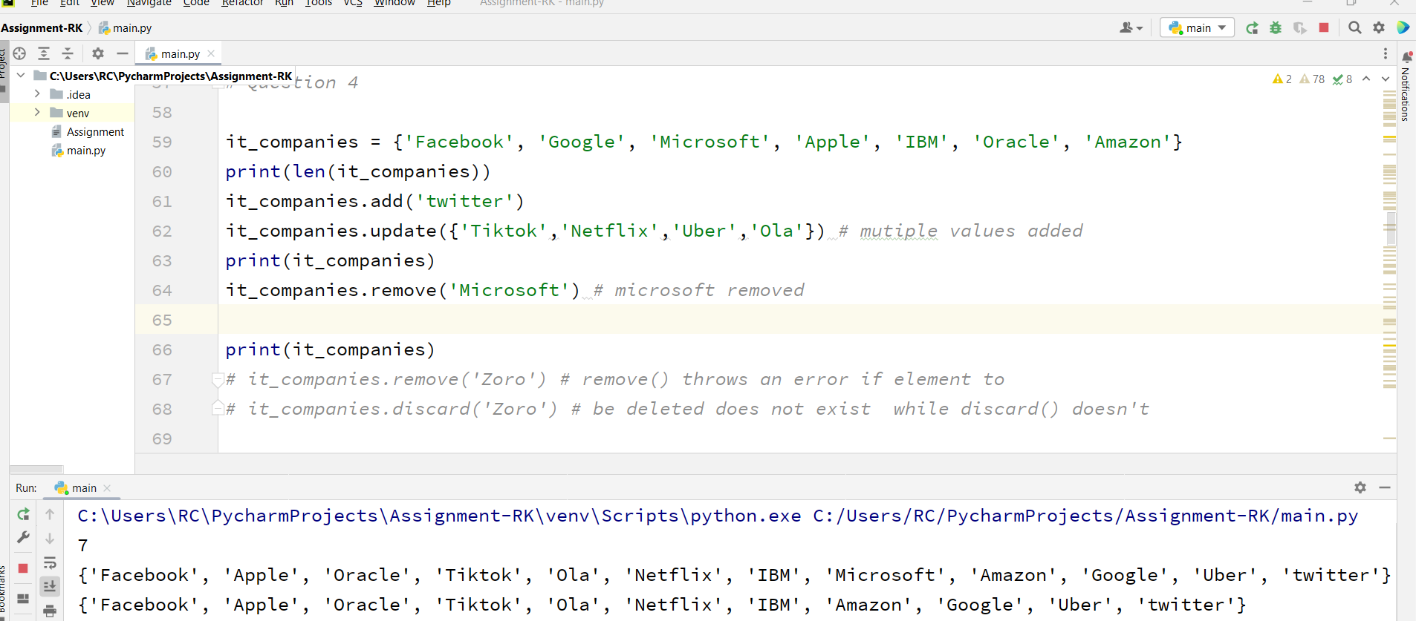

Question 5:

Calculated area 1 and assigned it to variable ‘area_of_circle’

Calculated circumference of circle

Calculated area 2 after taking radius as user input.

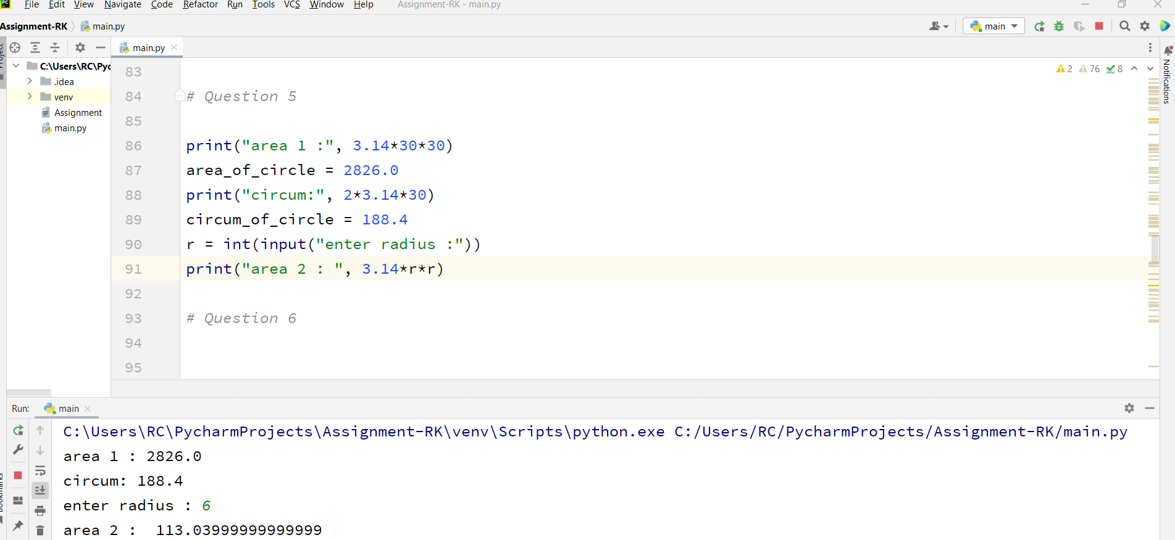

Question 6:

Created a string ‘str’ , splitted words and converted it to a list using split()

Converted the list to a set and assigned it to ‘unique_set’

Printed unique words at last.

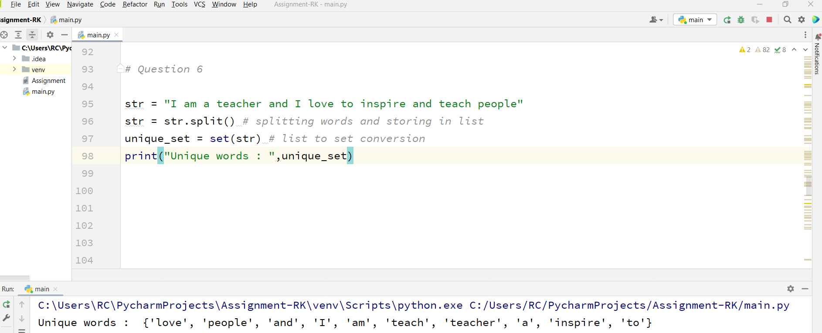

Question 7:

Used tab escape sequence to print the following lines.

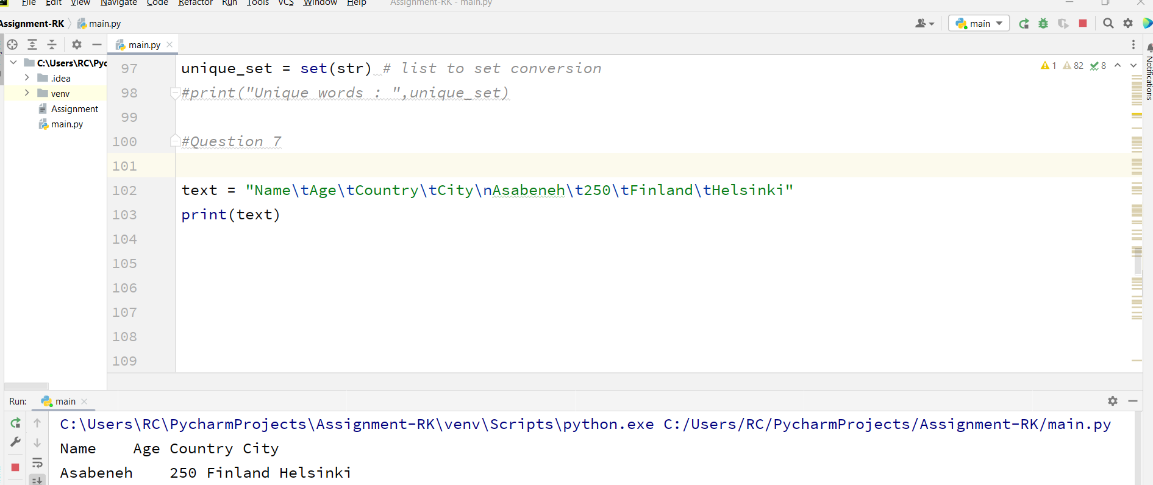

Question 8:

Assigned radius , calculated area using ‘f strings’ and displayed text with string formatting

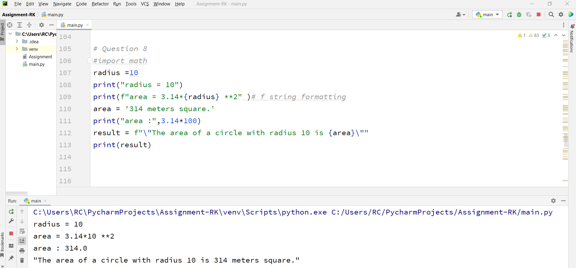

Question 9 :

Created empty lists L,L2

Took user input for finding number of students and assigned it to ‘N’

Used for loop to take weights from user and assigned them to variable ‘pounds’

Added weights in pounds to list ‘L’

Converted weights in pounds to kilograms and added them to list ‘L2’

At last, printed them successfully…

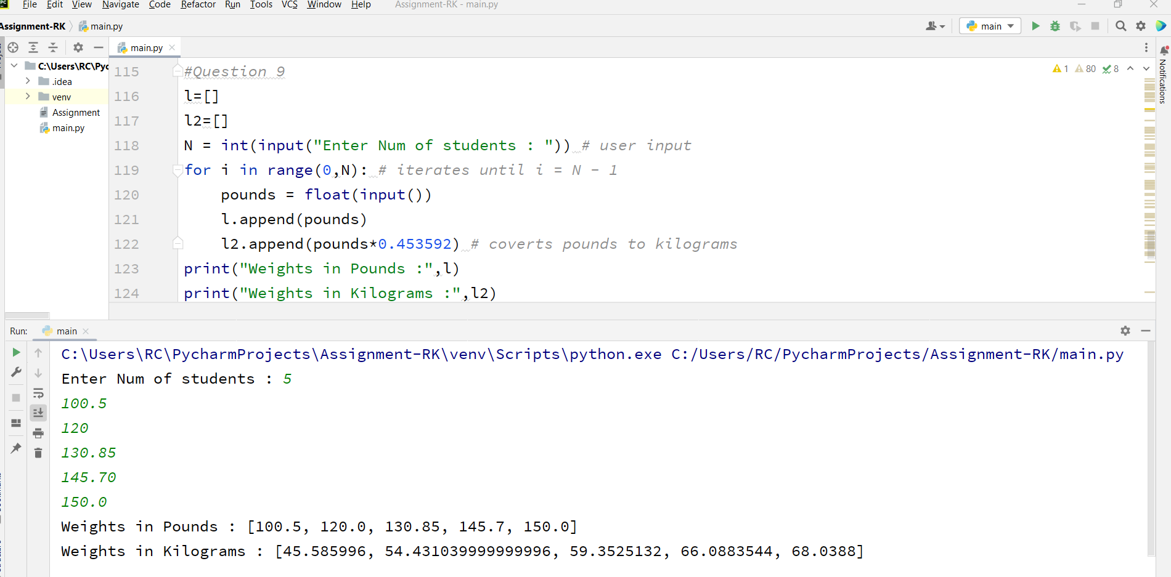

Question 10 :

Seperated dataset into two : Training and testing where K=3, input = classes of data sets,F= featurevalue

Calculated distances (D) from classes to K for all inputs.

As nearest neighbours 4,1 (majority values) belong to class ‘O’, K=3 is predicted to belong ‘O’.

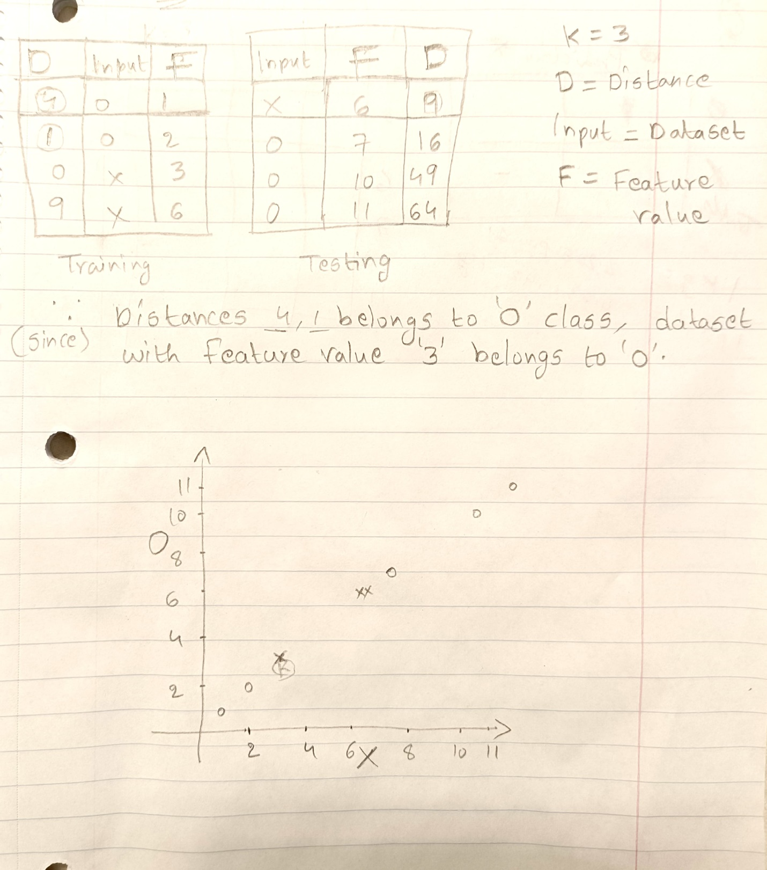

Sort() – to sort the list

Calculated median with middle position(6) which was obtained by dividing length of list (12)